HW 8

In this assignment we used the crank Nicolson method to approximate a 1 D heat diffusion example.

UUU % approximated values

|  |  |  |  |  |  |  |  |  |  |
| --- | --- | --- | --- | --- | --- | --- | --- | --- | --- |
| 0 | 0 | 0 | 0 | 0 | 0 | 0 | 0 | 0 | 0 |
| 0 | 1.97534632623559e-21 | 8.28311194026906e-21 | 3.27577749010571e-20 | 1.29078277713704e-19 | 5.08499122261510e-19 | 2.00318333903649e-18 | 7.89134024451000e-18 | 3.10871430183634e-17 | 1.22464679914735e-16 |
| 0 | 1.97534632623559e-21 | 8.28311194026906e-21 | 3.27577749010571e-20 | 1.29078277713704e-19 | 5.08499122261510e-19 | 2.00318333903649e-18 | 7.89134024451000e-18 | 3.10871430183634e-17 | 1.22464679914735e-16 |
| 0 | 1.97534632623559e-21 | 8.28311194026906e-21 | 3.27577749010571e-20 | 1.29078277713704e-19 | 5.08499122261510e-19 | 2.00318333903649e-18 | 7.89134024451000e-18 | 3.10871430183634e-17 | 1.22464679914735e-16 |
| 0 | 1.97534632623559e-21 | 8.28311194026906e-21 | 3.27577749010571e-20 | 1.29078277713704e-19 | 5.08499122261510e-19 | 2.00318333903649e-18 | 7.89134024451000e-18 | 3.10871430183634e-17 | 1.22464679914735e-16 |
| 0 | 1.97534632623559e-21 | 8.28311194026906e-21 | 3.27577749010571e-20 | 1.29078277713704e-19 | 5.08499122261510e-19 | 2.00318333903649e-18 | 7.89134024451000e-18 | 3.10871430183634e-17 | 1.22464679914735e-16 |
| 0 | 1.97534632623559e-21 | 8.28311194026906e-21 | 3.27577749010571e-20 | 1.29078277713704e-19 | 5.08499122261510e-19 | 2.00318333903649e-18 | 7.89134024451000e-18 | 3.10871430183634e-17 | 1.22464679914735e-16 |
| 0 | 1.97534632623559e-21 | 8.28311194026906e-21 | 3.27577749010571e-20 | 1.29078277713704e-19 | 5.08499122261510e-19 | 2.00318333903649e-18 | 7.89134024451000e-18 | 3.10871430183634e-17 | 1.22464679914735e-16 |
| 0 | 1.97534632623559e-21 | 8.28311194026906e-21 | 3.27577749010571e-20 | 1.29078277713704e-19 | 5.08499122261510e-19 | 2.00318333903649e-18 | 7.89134024451000e-18 | 3.10871430183634e-17 | 1.22464679914735e-16 |
| 0 | 1.97534632623559e-21 | 8.28311194026906e-21 | 3.27577749010571e-20 | 1.29078277713704e-19 | 5.08499122261510e-19 | 2.00318333903649e-18 | 7.89134024451000e-18 | 3.10871430183634e-17 | 1.22464679914735e-16 |

U_exact;

|  |  |  |  |  |  |  |  |  |  |
| --- | --- | --- | --- | --- | --- | --- | --- | --- | --- |
| 0 | -0.342020143325669 | 0.642787609686539 | -0.866025403784438 | 0.984807753012208 | -0.984807753012208 | 0.866025403784437 | -0.642787609686540 | 0.342020143325669 | -1.22464679914735e-15 |
| 0 | -5.11160682429639e-06 | 9.60667842630042e-06 | -1.29430428306190e-05 | 1.47182852505968e-05 | -1.47182852505968e-05 | 1.29430428306190e-05 | -9.60667842630042e-06 | 5.11160682429640e-06 | -1.83027609865472e-20 |
| 0 | -7.63946943946926e-11 | 1.43575061179774e-10 | -1.93438156644346e-10 | 2.19969755574467e-10 | -2.19969755574467e-10 | 1.93438156644346e-10 | -1.43575061179775e-10 | 7.63946943946928e-11 | -2.73540958882111e-25 |
| 0 | -1.14174456922590e-15 | 2.14577789304793e-15 | -2.89099873465944e-15 | 3.28752246227383e-15 | -3.28752246227383e-15 | 2.89099873465944e-15 | -2.14577789304793e-15 | 1.14174456922590e-15 | -4.08816223088646e-30 |
| 0 | -1.70637590959119e-20 | 3.20693770105937e-20 | -4.32069547642004e-20 | 4.91331361065056e-20 | -4.91331361065056e-20 | 4.32069547642003e-20 | -3.20693770105937e-20 | 1.70637590959120e-20 | -6.10989684848241e-35 |
| 0 | -2.55023656193721e-25 | 4.79287695702165e-25 | -6.45742565575891e-25 | 7.34311351895887e-25 | -7.34311351895887e-25 | 6.45742565575890e-25 | -4.79287695702165e-25 | 2.55023656193722e-25 | -9.13144767520647e-40 |
| 0 | -3.81141487364269e-30 | 7.16311686303137e-30 | -9.65084124239268e-30 | 1.09745317366741e-29 | -1.09745317366741e-29 | 9.65084124239267e-30 | -7.16311686303138e-30 | 3.81141487364269e-30 | -1.36472576727291e-44 |
| 0 | -5.69628855449769e-35 | 1.07055206410574e-34 | -1.44235089416480e-34 | 1.64018091955551e-34 | -1.64018091955551e-34 | 1.44235089416480e-34 | -1.07055206410574e-34 | 5.69628855449770e-35 | -2.03962885853856e-49 |
| 0 | -8.51329607818056e-40 | 1.59997630064638e-39 | -2.15564223848142e-39 | 2.45130590846443e-39 | -2.45130590846443e-39 | 2.15564223848141e-39 | -1.59997630064638e-39 | 8.51329607818058e-40 | -3.04829437557723e-54 |
| 0 | -1.27234091850102e-44 | 2.39121874447875e-44 | -3.22168029924223e-44 | 3.66355966297978e-44 | -3.66355966297978e-44 | 3.22168029924223e-44 | -2.39121874447875e-44 | 1.27234091850103e-44 | -4.55577913661888e-59 |

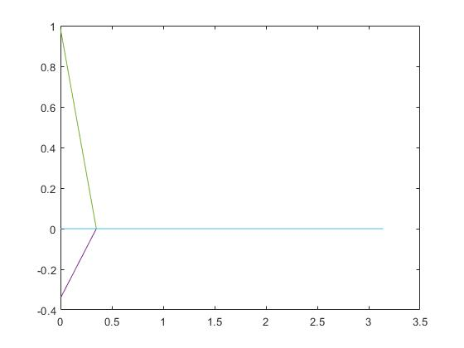Figure 1 comparing UUU to U_exact;

So, what is supposed to happen is that as the number of nodes increases, the error between the approximate values and the exact solution should begin to converge. Increasing the number of nodes decreases the deltaX and deltaT values which makes the solution more grid independent resulting in a lower discretization error. Crank Nicolson method is ideal because of the higher order error for delta x and delta t.